**Cost Management**

**Azure** **Subscriptions :**

**Login Azure** **Portal : Go to Subscription ==> add subscription**

1. Free trial
2. Pay as you go
3. Azure Students

**Azure** **Purchasing :**

1. Enterprises
2. Web Direct
3. Cloud Solution Provider

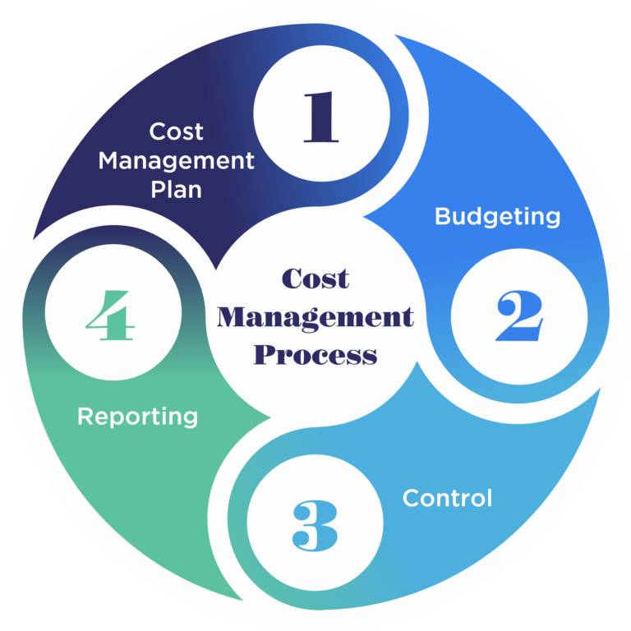

### **1. Resource Usage**

* **Pay-as-you-go model**: Costs are directly tied to how much compute, storage, and network bandwidth you use.
* **Idle resources** (e.g., running VMs not in use) can still incur charges.

### **2. Service Type**

* Different Azure services (VMs, Azure Functions, App Services, Databases) have different pricing models.
* Example: A **PaaS** service like Azure App Service may cost less than managing your own **VM (IaaS)**.

### **3. Region/Location**

* Pricing varies by **Azure region** due to differences in data center infrastructure and energy costs.
* Example: Running a VM in **East US** might be cheaper than in **West Europe**.

### **4. Resource Size and Tier**

* Larger VMs (e.g., D-Series vs. B-Series) or premium tiers (e.g., SQL Database Premium) cost more.
* Choose sizing based on workload needs.

### **5. Scaling (Vertical/Horizontal)**

* **Auto-scaling** can save money during low usage but may increase costs during peak times.
* Manual over-provisioning leads to waste.

**6. Reserved Instances**

* Committing to 1 or 3 years of resource usage via **Reserved Instances** significantly reduces cost vs. pay-as-you-go.

### **7. Licensing**

* Bring Your Own License (BYOL) for Windows or SQL Server can reduce costs if you already own licenses.

**8. Uptime and Scheduling**

* Non-production workloads can be **shut down during off-hours** to reduce cost.
* Use **automation scripts** or **Azure DevTest Labs** to schedule.

**9. Network Traffic**

* Inbound traffic is usually free; **outbound (egress)** data transfer costs money.
* High data movement between regions or external networks increases cost.

**10. Monitoring and Management Tools**

* Using services like **Azure Monitor**, **Log Analytics**, and **Application Insights** adds cost.
* But they help optimize performance and cost if used wisely.

### **11. Tags and Resource Grouping**

* Poor tagging and organization can lead to **wasted spend** and make it hard to track cost per team/project.